THE BELOW ARE TRAININGS WE HAVE DEVELOPED AND CURRENT LOCATION. THESE NEED TO BE ORGANIZED IN THE RESOURCES SUB PAGES

Programming training hub

**AI Training Hub - Interactive Learning Portal - 6 Comprehensive Learning Modules**

<https://mcsibopi.gensparkspace.com/>

**Understanding Perplexity Spaces and Gemini Gems**

<https://xzkesftp.gensparkspace.com/>

**Using Perplexity Spaces and Gemini Gems as Project Hubs**

<https://qbhmxamv.gensparkspace.com/>

**Top 20 AI Tools Under $20/Month**

**Using Claude and ChatGPT for Projects**

<https://tschoycb.gensparkspace.com/>

### 

### **Utilizing Notebook LM**

<https://jytqzykt.gensparkspace.com/>

# **Prompt Engineering 101**

<https://vphicieu.gensparkspace.com/>

**AI Fundamentals for Beginners**

<https://fovhttac.gensparkspace.com/>

**Engineering Alignment of Context, Prompt, and Model**

<https://tbeclekg.gensparkspace.com/>

**Using Claude and ChatGPT for Projects**

<https://tschoycb.gensparkspace.com/>

**\*\*\*\*\* FROM RESOURCES (TOP SECTION - 1)**

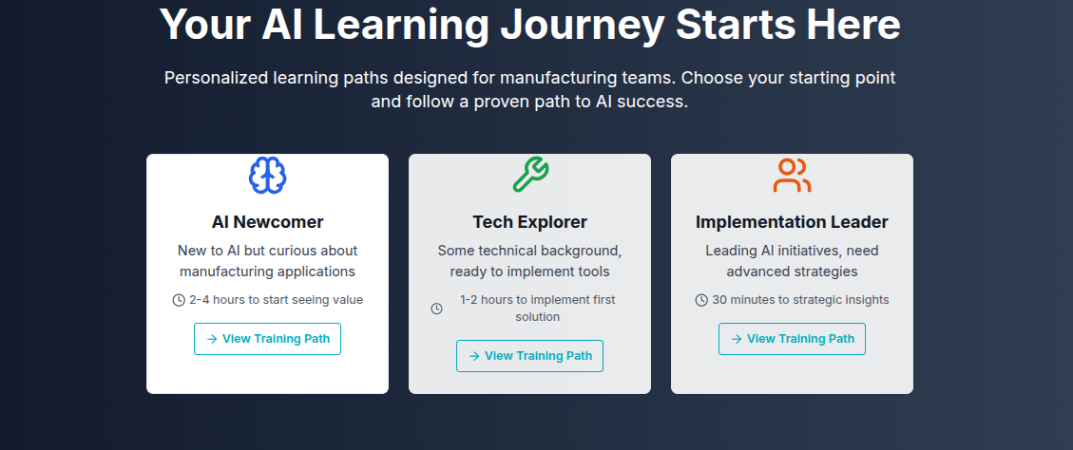

**For each of these 3 sub-pages, these sections need to be developed:**

**\*\*\* AI Newcomer Training Path**

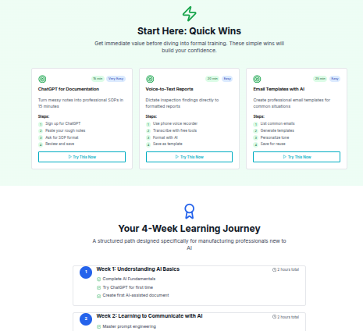

**\*\*\* Tech Explorer Training Path**

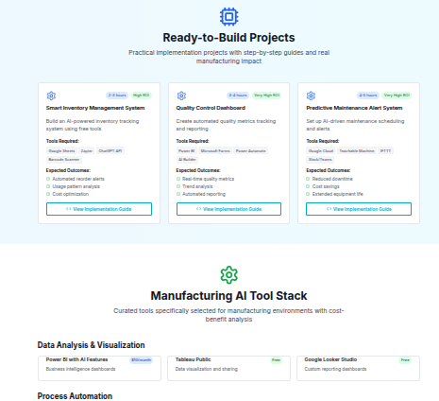

# **\*\*\* Implementation Leader Training Path**

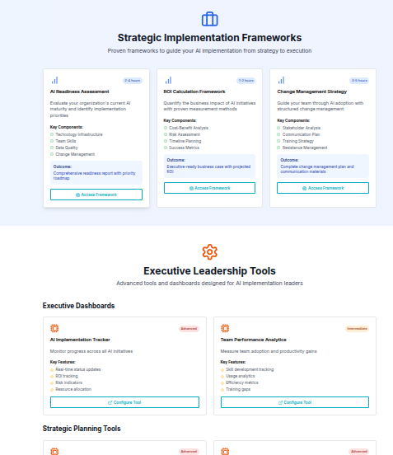

Resources section 2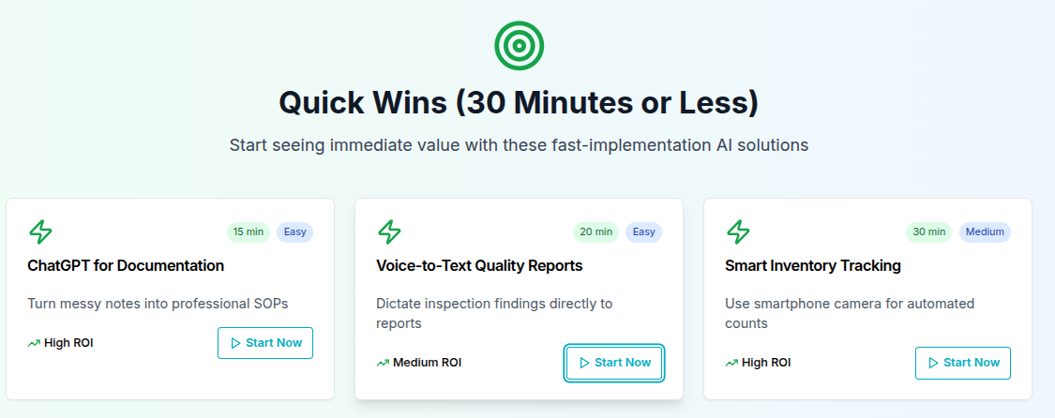

Resources 3

